Dear Brothers and Sisters,

May the peace of the Lord be with you! John 8:31. To those who had believed him, Jesus said,

“If you hold to my teaching, you are really my disciples.”

We’ve talked about many Biblical truths over these past few months. Jesus Christ reminds us that “true Christians obey the Word.” Brothers and sisters, time is short. We are getting closer and closer to the end of the life. The exact time when the end comes is different for each person, it may be several decades, five years, two years, five months, or a week. We do not know when, only God does. If the Bible has ever touched our hearts, then we are someone God will save. “Do not merely listen to the word…do what it says” (James 1:22). God loves us and doesn’t want us to arrive at the Holy Mountain empty-handed, so over and over the Bible tells us to obey the Word seriously. Try thinking about this: when we look in the mirror and see some dirt on our faces but don’t move to wipe it away, then what good does the mirror do us? Suppose we read the Bible see that it says, “If you forgive others, you Heavenly Father will also forgive you,” but afterwards we keep on holding a grudge, then what good does reading the Bible do us? God love us too much, He doesn’t want us to lose our treasures, and to receive the Lord’s forgiveness is a treasure.

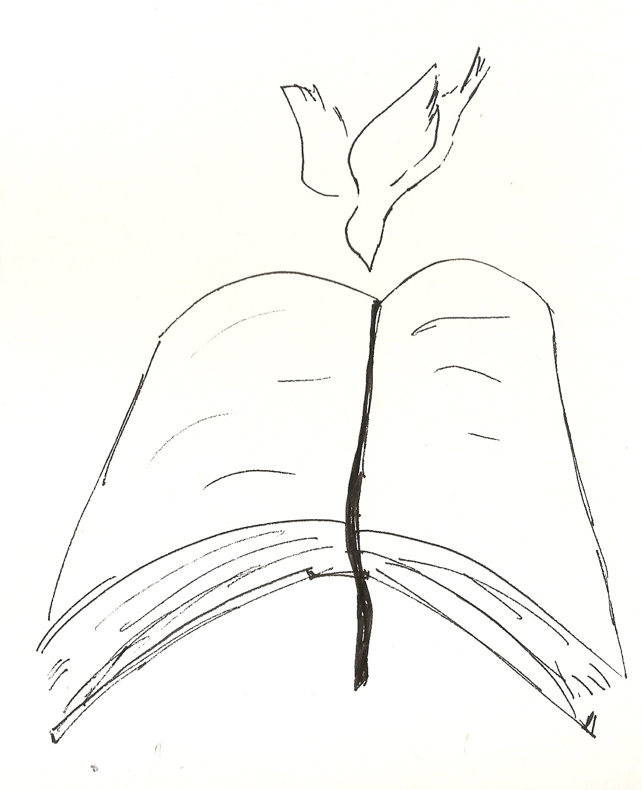
About a year ago, I was talking to a friend about the Biblical truth that “love is patient.” To my surprise, he immediately called a relative he’d hated for more than ten years to ask how they were doing. It turns out that due to being hurt from some incident, his heart had been ensnarled all this time by one emotion, one thought: “I’ve loved you all these years, how could you treat me like this! Even till the day I die, I won’t forgive you!” In this world, many people are bound by this same thing. They can’t fee themselves, and so they spend a lifetime hating, hating, hating.

But when my friend learned that “true love is everlasting patience,” he wanted to put into practice this “true love,” this “unconditional love,” the kind of love that “forgives 70 times 7 times.” The Bible’s words touched his heart and untied the roped of resentment. Jesus said, “You will know the truth, and the truth will set you free.” Again, the Bible say,” Who the Son sets free, they are free indeed.”

