Dear Brothers and Sisters,

May the peace of the Lord be with you! Hebrews 3:13

“But encourage one another daily, as long as it is called Today, so that none of you may be hardened by sin’s deceitfulness.”

The three major earthquakes these past few weeks once again reminds us of what the Bible says: “For we do not have an enduring city, but we are looking for the city that is to come, we are looking forward to a new heaven an and new earth” (Hebrews 3:14, 2 Peter 3:13). First came the big earthquake in Haiti, which killed hundreds of thousands; next came the quake in Chile, which was 500 times stronger than the one that hit Haiti; and after that came the earthquake in Taiwan. Geologists reminded us Oregonians that Oregon and Washington are located in a seismic zone. The last major earthquake here occurred more that a hundred years ago, and so we should make good preparations and store up some non-perishable foods, water, batteries, and so on.

In reality, we “do not even know what will happen tomorrow” (James 4:14). God may take us away at any time. We don’t need to be overly concerned about the big earthquake, but we still should “encourage one another daily, as long as it is called Today.” Why? Because the Bible says that some people among us will be led astray by sin and their hearts will harden. In other words, our heart will be deceived by evil, the door will close and we will no longer accept the truth. What is this “evil?” For example, “every man for himself,” “you wrong me once and I’ll pay you back 15 times,” “money is the only thing that can be trusted,” etc.
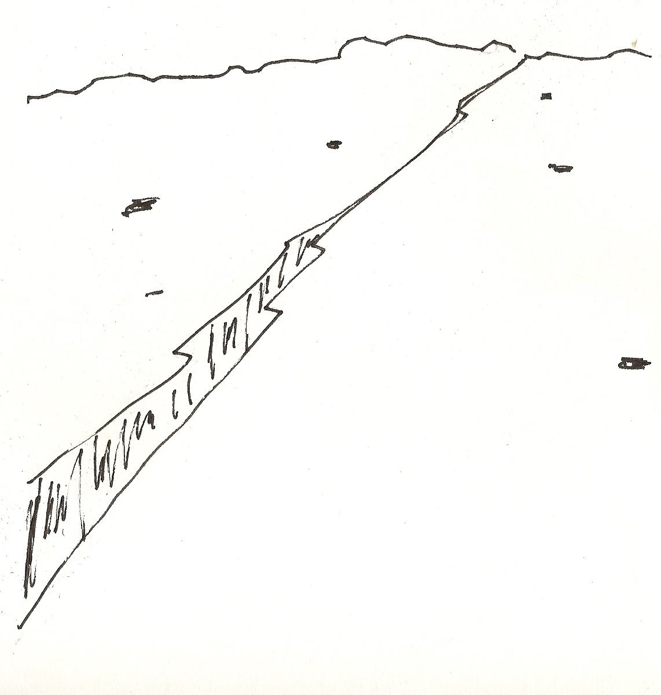
These “evils” will enslave and harm us, because they war again God’s love and poison our souls. We may encourage one another in saying, “if we love one another, God lives in us and his love is made complete is us” (1 John 4:12). One day, there will be a large incinerator in the universe where all these “evils” will burn, and then a “new heaven and new earth” will appear. The Bible calls this incinerator the “lake of fire.” Let us daily encourage one another that the precious blood of Christ, through the truth of the Bible, cleanses our souls. We are not headed for the lake of fire, but for the new heaven and new earth.

