Dear Brothers and Sisters,

May the peace of the Lord be with you! Galatians 5:22-23

“But the fruit of the Spirit is love, joy, peace, patience, kindness, goodness, faithfulness, gentleness and self-control.”

My favorite fruit is the Asian pear. Just imagining the pear in front of me, the refreshing sweetness of the juice as I bite into it, already leave me with a sense of joy and satisfaction. But the Bible says that the fruit of the Spirit in our lives is a good character. The sad thing is, there are les and les people whose lives are filled with the fruits of life, and to be fortunate enough to sit next to one of them and talk with them can be considered one of the biggest joys in life.

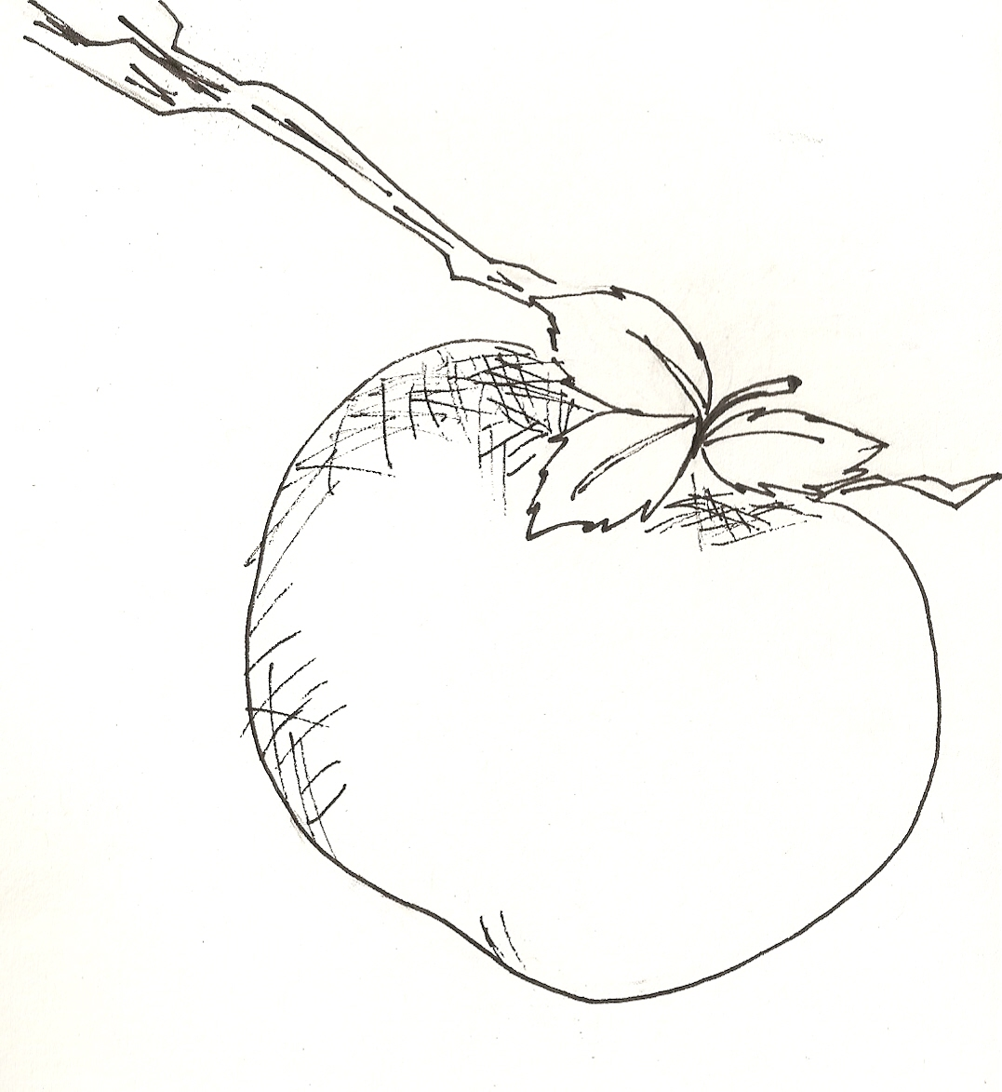
Everyone wants to eat and drink good things, but to seek to enter the Kingdom of God is to seek things better than eating and drinking. The Bible says, “For the Kingdom of God is not a matter of eating and drinking, but of righteousness, peace and joy in the Hold Spirit” (Romance 14:17). The Bible also says, “Build yourselves up in your most hold faith and pray in the Hold Spirit.” If we are very familiar with the truths of the Bible, and we let the Holy Spirit led us in prayer, we will gradually be able to the bear the fruits of love, joy, peace, patience, kindness, goodness, etc. I know someone who, after only two years of knowing Jesus, had a huge change in their character and even in their countenance. His nickname had been “Big Bull” (because of his short temper), but in the one to two years after he came to know Christ, he came to love reading the Bible and praying. Without even knowing it, he started to bear the fruits of the Spirit. A brother, face to face and looking him in the eye said to him, “God has really changed you!” His mother, even though she prayed to her ancestors, gave him a cross, saying, “Knowing Jesus has been good for you.” Once when some old classmates got together for a reunion over dinner, an old friend, after carefully observing him for a while, said, “I feel as though you’ve gone through some change that’s not merely due to time, like a cloth that’s been put into bleach and taken out again.”

Many people hope that their daughter will one day marry a man of good character and much wealth. But if you could not have both, which would you choose? Haha! I have already thought it through: I ask God to prepare for my daughter a Prince Charming with good character, full of the fruit of the Holy Spirit. Praise the Lord, and Amen!

