Dear Brothers and Sisters,

May the peace of the Lord be with you! Proverbs 22:6

“Train a child in the way he should go, and when he is old he will not turn from it.”

The greatest mission of any parent is to teach his child to walk down the right path. This is not a one-time, instant impartation of head knowledge. Rather, it is continually guiding and teaching the child, so that after many years’ worth of experiences he will be able to say, “Mom and Dad were right, their characters were good, and as a person I should strive to be like them.”

General MacArthur wrote a prayer for his children. At the time, he was already an accomplished man. He had participated in both the first and second World Wars as well as the Korean War, and had received many medals of honors for his services. But when he left the army in 1951, he did not feel that he had fulfilled all his obligations and responsibilities. Instead, his heart and mind were on his son. In May 1952, he wrote the following prayer:

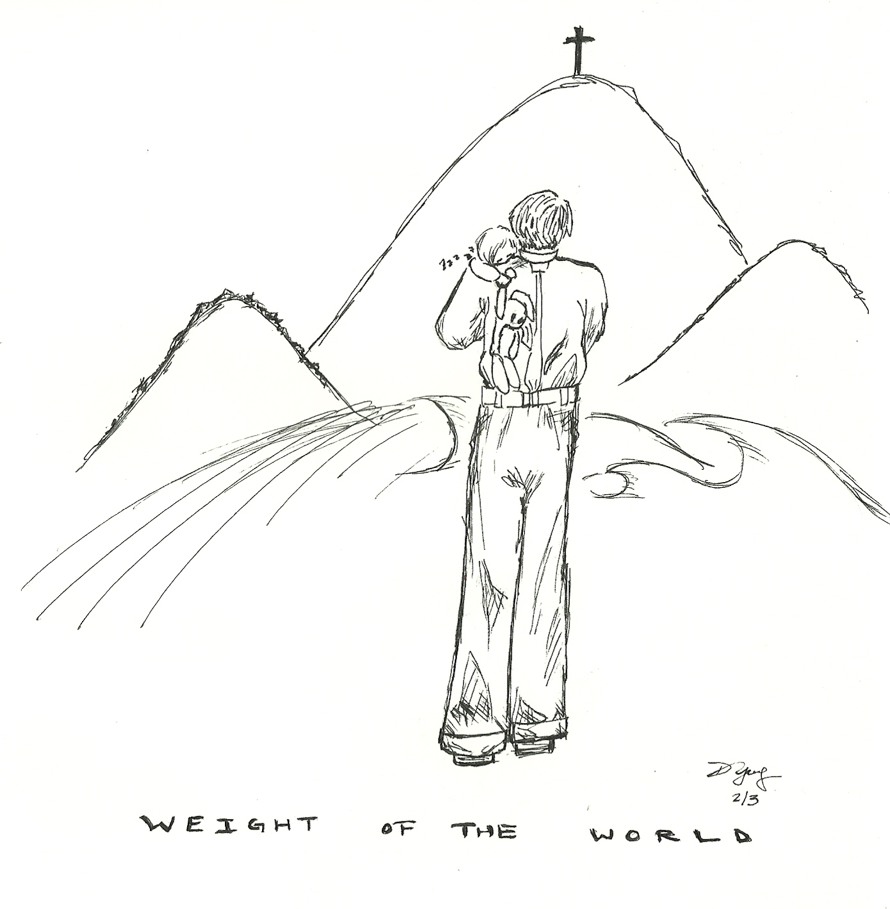
Build me a son, O Lord, who will be strong enough to know when he is weak, and brave enough to face himself when he is afraid; one who will be proud and unbending in honest defeat, and humble and gentle in victory.
Build me a son whose wishbone will not be where his backbone should be; a son who will know Thee….Lead him, I pray, not in the path of ease and comfort, but under the stress and spur of difficulties and challenge. Here let him learn to stand up in the storm; here let him learn compassion for those who fail.
Build me a son whose heart will be clean, whose goal will be high; a son who will master himself before he seeks to master other men; one who will learn to laugh, yet never forget how to weep; one who will reach into the future, yet never forget the past.
And after all these things are his, add, I pray, enough of a sense of humor, so that he may always be serious, yet never take himself too seriously. Give him humility, so that he may always remember the simplicity of greatness, the open mind of true wisdom, the meekness of true strength.
Then I, his father, will dare to whisper, “I have not lived in vain.”

