Dear Brothers and Sisters,

May the peace of the Lord be with you! In 2 Timothy 4:6-7, at a time when the apostle Paul was close to death, he wrote the following words:

“The time has come for my departure. I have fought the good fight, I have finished the race, I have kept the faith.”

He went on to say, “From now on, God has treasures stored up for me.” This statement reminds me of Mother Teresa and how, when the world’s attention was fixed entirely on the funeral of Princess Diana, she quietly passed away. Perhaps it was God answering her prayers, because she spent a lifetime doing her best to avoid the press and paparazzi. Once, she asked a reporter, “Why are you interviewing me? I am only lifting up the people who lay dying in the street that they may leave this world in God’s love.” Mother Teresa never chased after fame, as “it is enough that God knows.” In just ten seconds of TV coverage, her words touched my heart so deeply that they have been my light for ten years: “God has not called me to be successful; He has called me to be faithful.” She fought her battle wholeheartedly to the end, ran the race, held fast to her faith, and now rests in God’s embrace, enjoying His love with all the people she had served.

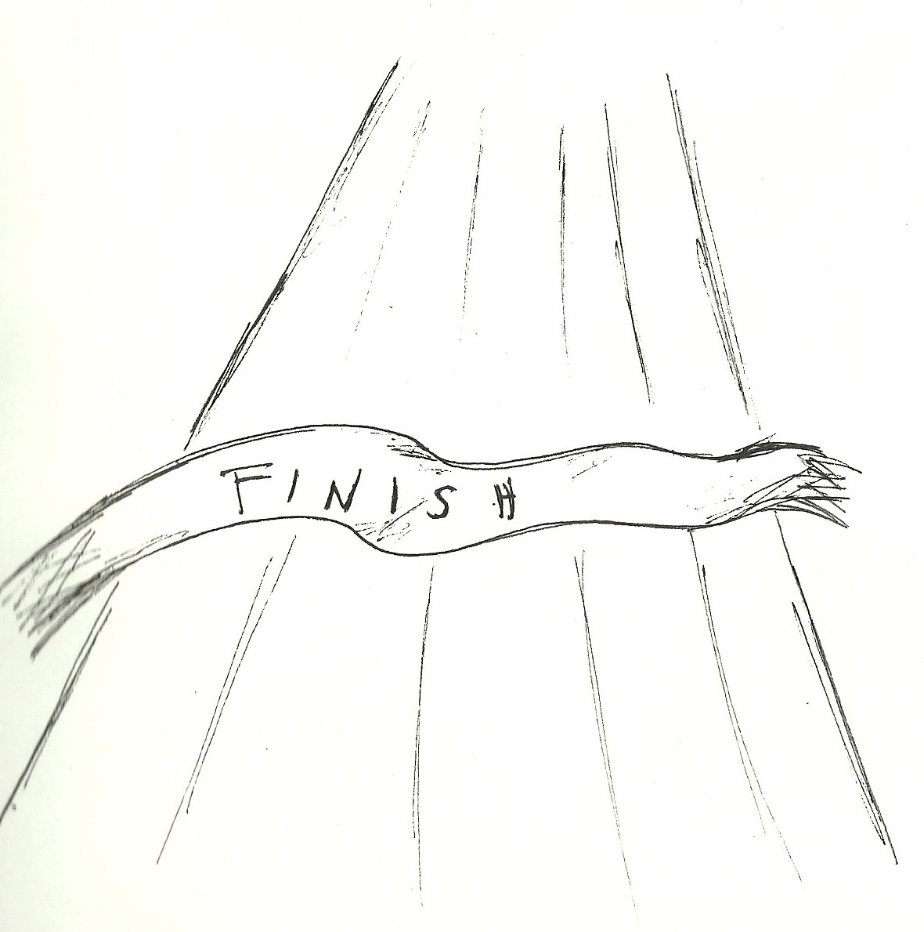
I asked the Heavenly Father, “Lord, how much do I still have to fight? How much longer is my race?” He brought to my mind my nephew, who spent his whole life in and out of hospitals due to illnesses, who went through all sorts of pain and finally finished his life’s journey before turning seven. The day before he died, when he needed to get his blood drawn, he said, “Mommy, I don’t want to do these things anymore.” But at seeing his mother upset, he bravely accepted the procedure anyway. In the hospital room where he passed away, when no one knew quite what to say, my older brother-in-law spoke up, “Dennis, you pray!” God move me to pray this prayer, “Heavenly Father! Thank you that he has fought the good fight, finished the race he was meant to run, loved the parents he was meant to love, and that from now on he will enjoy Your love from within Your embrace.” We do not know how long our journey is, each difficulty may very well be our last test. “Now it is required that those who have been given a trust must prove faithful” (1 Corinthians 4:2). Let this be our prayer, “Lord, would you let us fight our war faithfully and run our race well until the day we see you face to face.”

