Dear Brothers and Sisters,

May the peace of the Lord be with you! Philippians 2:4-5

“Each of you should look not only to your own interests, but also to the interests of others. Your attitude should be the same as that of Jesus Christ.”

There were 30 people lost in a desert. They were all very dehydrated, and just when they couldn’t hold out any longer, they suddenly discovered an abandoned little house, and in that house – a water pump! Excitedly, they pumped the handle up and down, but not even half a drop of water came out. They were disappointed, but when they looked on the shelves they found hundreds of bottles, 10 of which were filled with water (the others were empty). They also found a note that read: “put five bottles of water into the mouth of the water pump, then pump the handle 20 times. Water will come out. Before you go, please leave behind 10 bottles of water.”

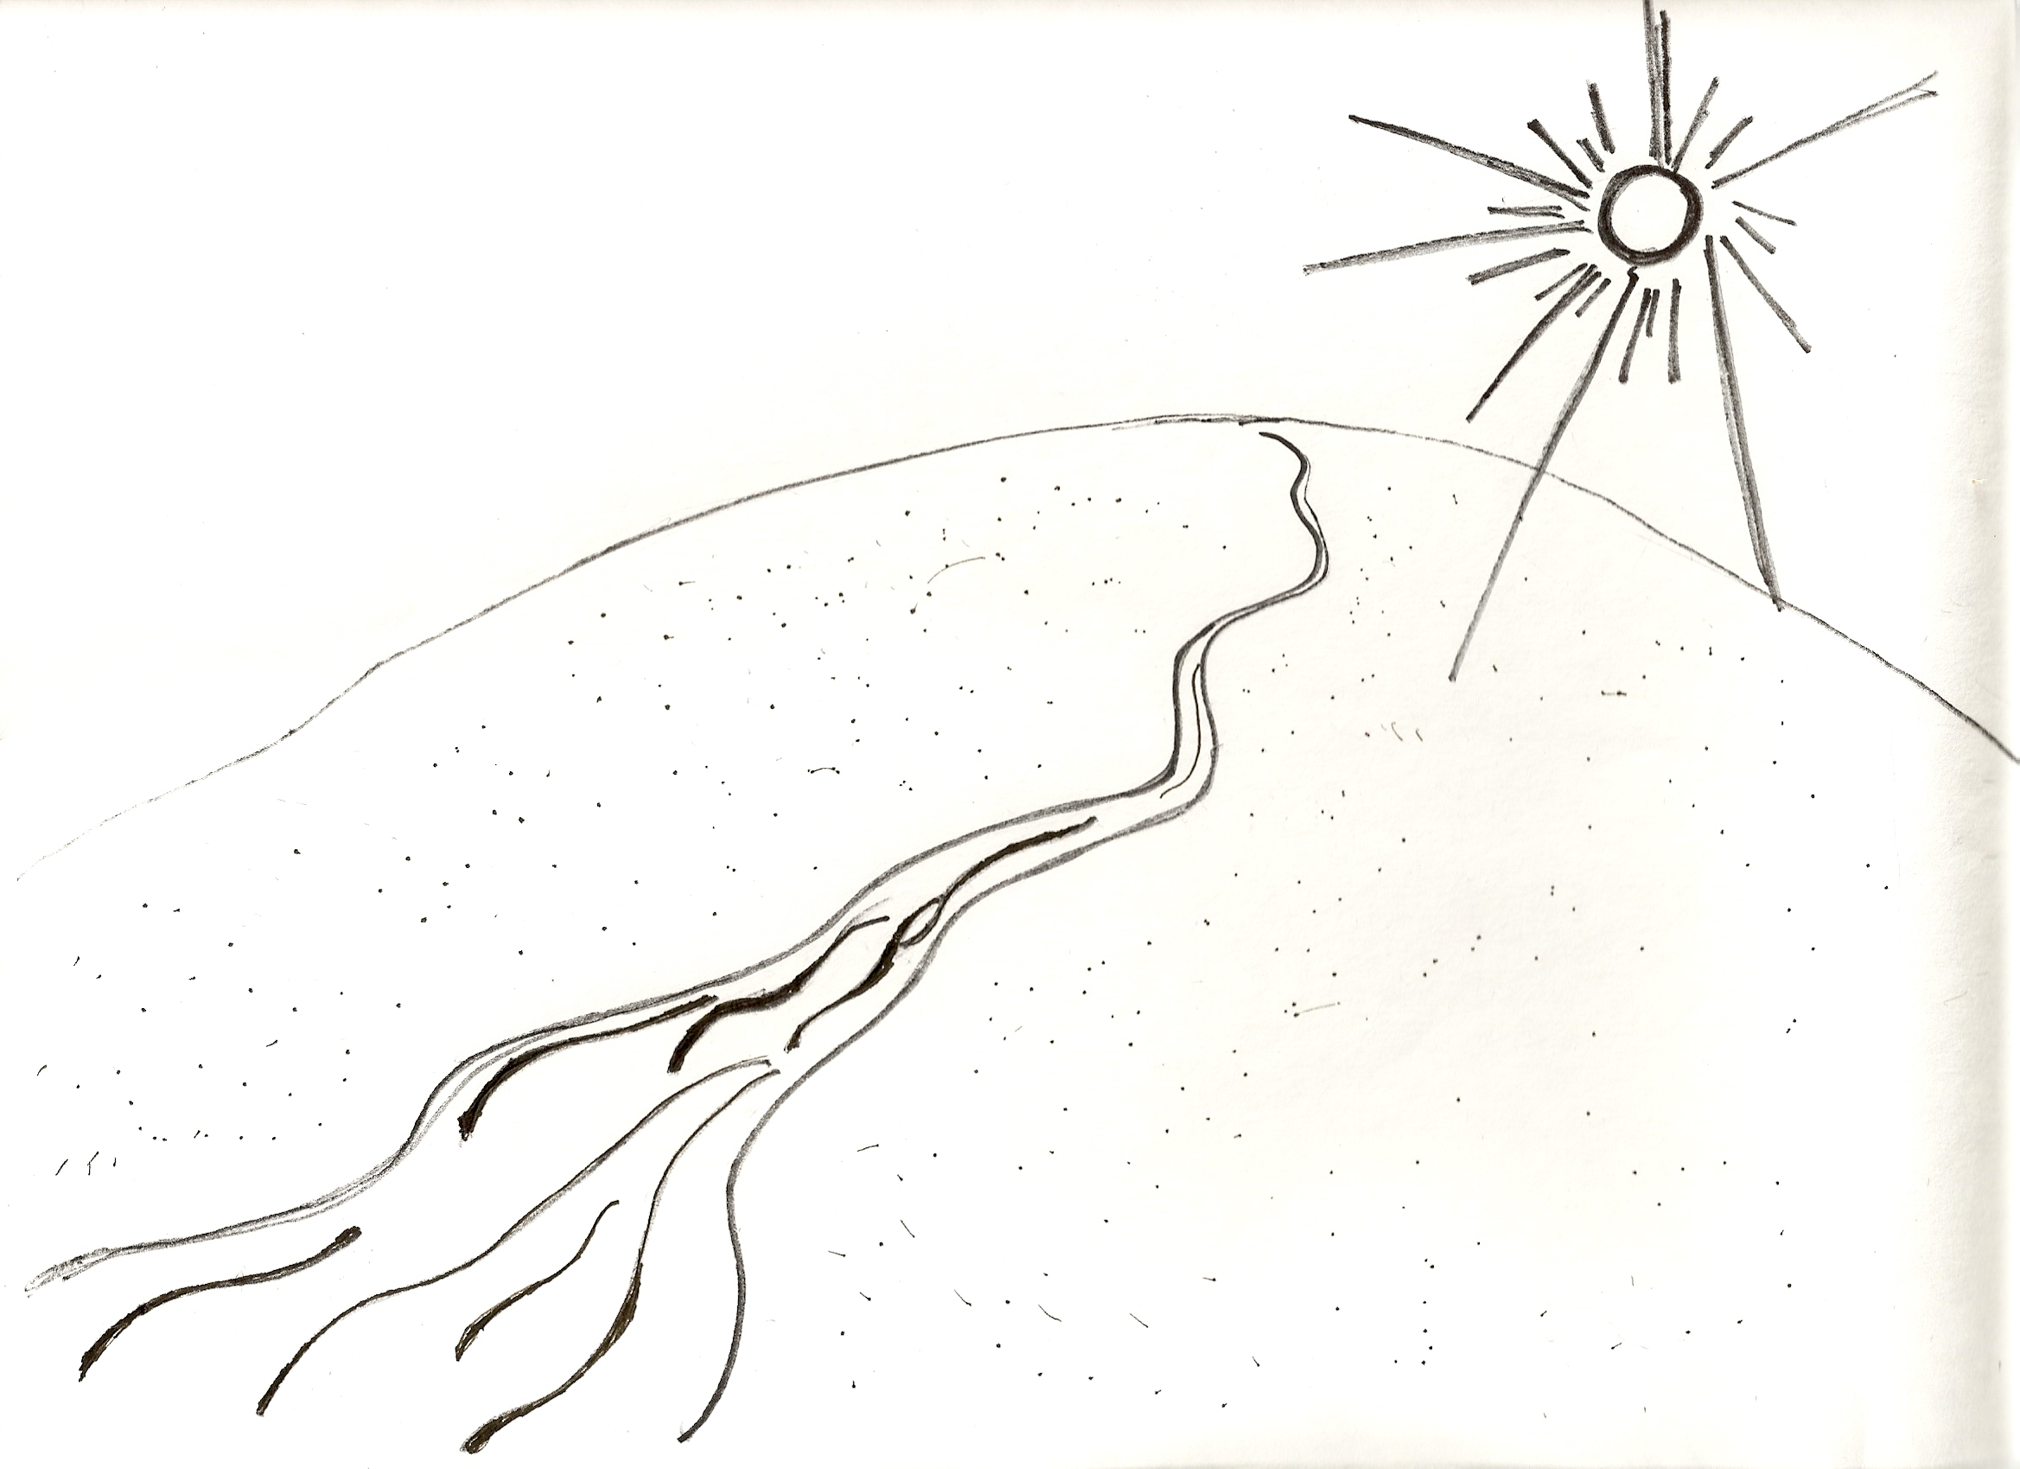
10 of them each took a bottle of water, feeling conflicted inside: “If I take a chance and do as the note says but it doesn’t work and the water doesn’t come, I’ll die of thirst in this place.” In the end, 5 of them immediately drank their bottle of water and hurriedly left, in the hopes of escaping the desert before they really die of thirst. The other 5 could not bear to see their companions die, and decided to pour all of their bottles into the old, broken-looking water pump. Then they pumped the handle gently – one, two, one, two – and praise God! Water started to pour abundantly out. Each of them drank their fill, and then they refilled 10 bottles with water and sealed them with corks. To the end of the original note, they added, “Trust us, it’s true.” Then each took a few extra bottles of water, and they continued trying to find their way out of the desert.

On their way out, they found the bodies of the five who had drank their bottles and left first. They buried them before going ahead. We don’t know whether they made it out of that desert, but the Bible says, “God is love. He who lives in love, lives in God.” Loving one another is a road to eternal life. Yes, our love and our strength may amount to only a small bottleful. But let us teach in our families and our churches to pour out our love! Jesus Christ will certainly become in us a river of living water. To look out only for yourselves is a road leading to death, because your souls will become like an endless desert with no way out.

