Dear Brothers and Sisters,

May the peace of the Lord be with you! Matthew 11:28:

Jesus said: “Come to me, all you who are weary and burdened, and I will give you rest.”

Hold a glass of water for a minute, it’s easily doable; hold it for an hour, perhaps the hand starts getting sore; hold it for a day, and it might become necessary to call an ambulance. The weight of the water didn’t change, but the more we hold it, the heavier it feels. What we have to do is set the glass down and take a break before picking it back up again, and in this way we can hold it longer than before.

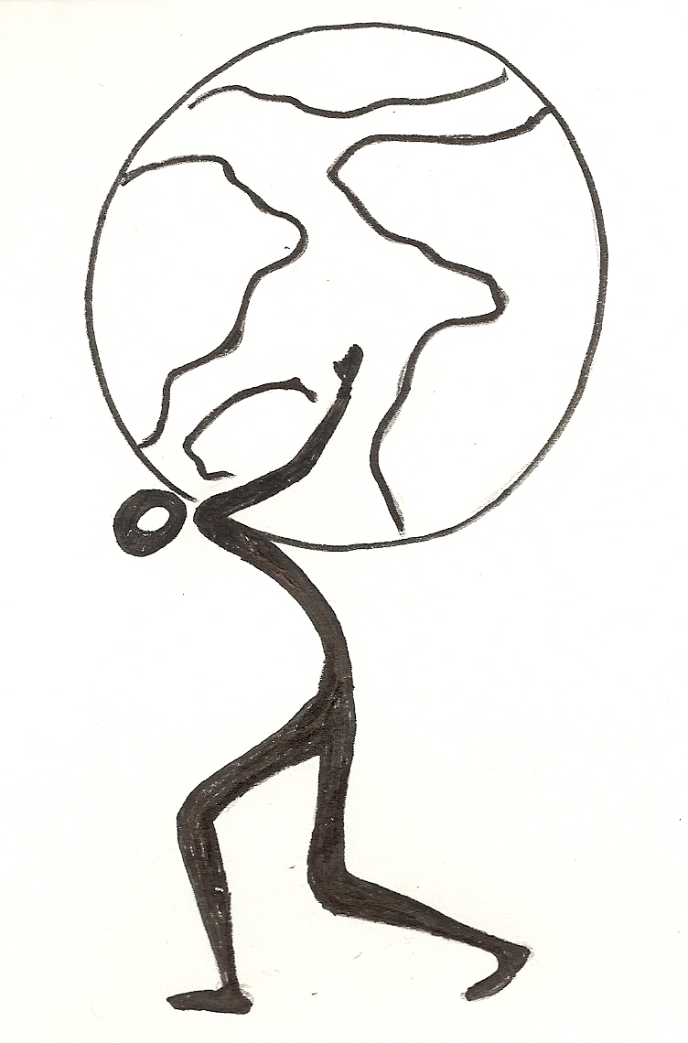
If we keep carrying this or that burden or responsibility, it gets way too tiring. Set it down, take a break, and come back to it in a little while. What is that burden? It might be a child’s education, parents’ heath, a long-established family business, the future of a career, or responsibilities from a certain group. Jesus calls to those of us who are weary and burdened to come to Him, to entrust our burdens to Him, to rest a while, and to enjoy the peace found in Him. Yes, God has entrusted us with certain things, but we also need to learn to give those back to Him. Think of this: when wild geese fly in V-formation, the leader uses the most energy while the ones following behind him are able to ride his draft and have an easier time flying. When the leader gets tired, he retreats to the back, letting another goose take the lead. In this way, the entire flock of wild geese can fly a long time until they reach their destination.

There was a father who was constantly worrying about everything regarding his family, his church, and his workplace. His clever wife prayed during one family prayer, “Father, I think You can rest a while, because my husband has already put everything on his own shoulders.” The children couldn’t help but laugh, then the husband joined in, and in the end the whole family laughed together for a few minutes. Then the husband prayed, “Father God, forgive me! I had forgotten about Your love and power. I give my family to You, my church to You, and my work to You. I’m tired now, I will rest a while.”

